**Lab 18. Performance Analysis**

V1.0

30/05/2020

We finally have an application with UI, local DB, and network connection. It is the time to run the App and analyse its performance. The following indicators are considered.

* CPU
* Memory
* Network
* Energy

The Android Studio embedded tool “Profile” is used in this tutorial to collect data. Below are the topics of this tutorial.

**Topics**

**1.** **Collecting performance data with “Profile” tool** 1

**Step 1.** **Setup application.** 1

**Step 2.** **Start “Profile” tool and collect data** 1

**Step 3.** **Analysis the data** 2

1. **Collecting performance data with “Profile” tool**
   1. **Setup application.**

It is recommended to launch an application with network interaction. So that download / upload data will be collected

* 1. **Start “Profile” tool and collect data**

Use this [tutorial](https://developer.android.com/studio/profile/android-profiler) to learn how to start the tool and how to collect data with it. The following data is collected for the start-up stage of the App created in Lab 17. In the App, CRUD function were performed when the MainActivity is launched.

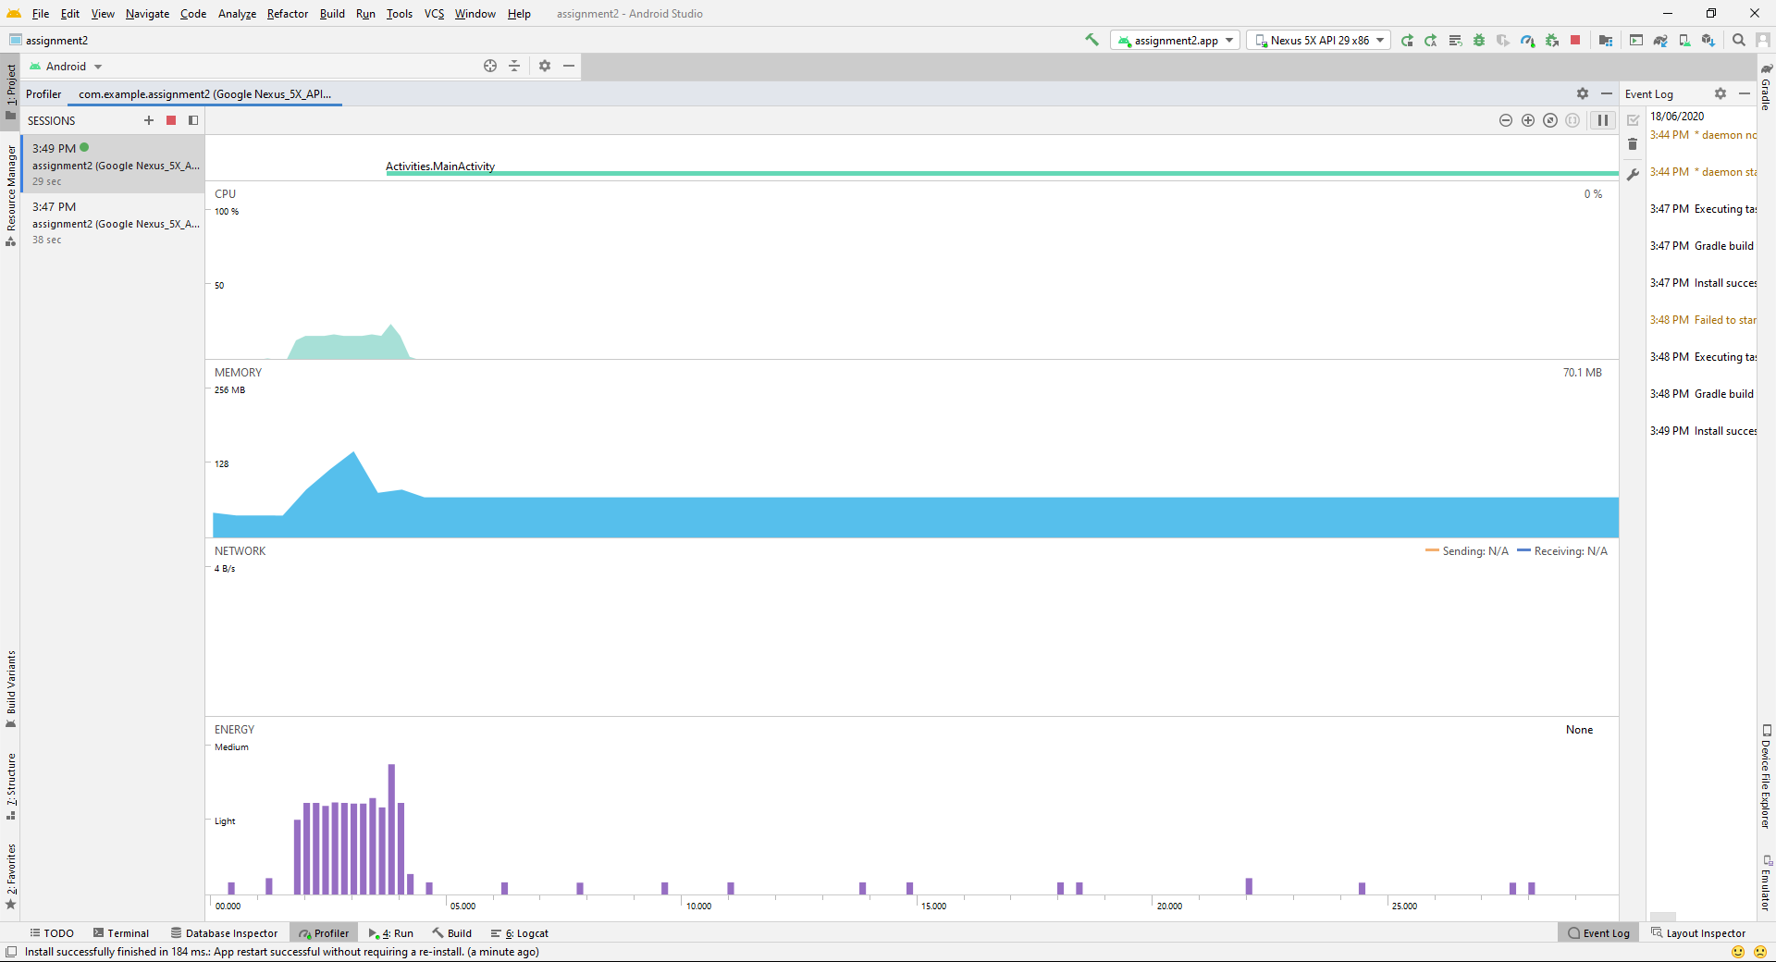

* 1. **Analysis the data**

Here is an example how to analyse the data. First, identify what the action was taken. Then analysis the graph seen in the tool

***Action #1****: Start up the App*

**CPU:**

* During Start Up, CPU usage spike occurs straight away and spikes up to >128 mb.
* After 3.00s the CPU usage drops to 0%
* Another CPU usage spike occurs at 14.00s with a peak usage of 53%
* CPU Usage stabilizes at 0% after 25 seconds.

**Memory**

* Memory usage from 0.00s ~ 20.00s spiking to 128mb
* After 20.00, memory usage lowers to 60.00MB and remains 60.00MB for the remaining duration of the test.

**Network**

* Not really using anything past 4 b/s

**Energy**

* Energy graph follows the same pattern at the CPU graph.

End of this tutorial